**COMPETITOR SITE AUDITS**

**Symbolic IO Corporate Website**

**Document Status:** FINAL

Document Date: 03/26/2015

**Contributors:**

Jesse Rafalko

Table of Contents

EMC 3

LAYOUT 4

DESIGN 5

RESPONSIVE DESIGN 6

HP Storage 7

LAYOUT 8

DESIGN 9

RESPONSIVE DESIGN 10

IBM Storage 11

LAYOUT 12

DESIGN 13

RESPONSIVE DESIGN 14

NetApp 15

LAYOUT 16

DESIGN 17

RESPONSIVE DESIGN 18

Pure Storage 19

LAYOUT 20

DESIGN 21

RESPONSIVE DESIGN 22

GOOGLE SEARCH RESULTS 23

UI Sugar Reference Sheet 24

# EMC

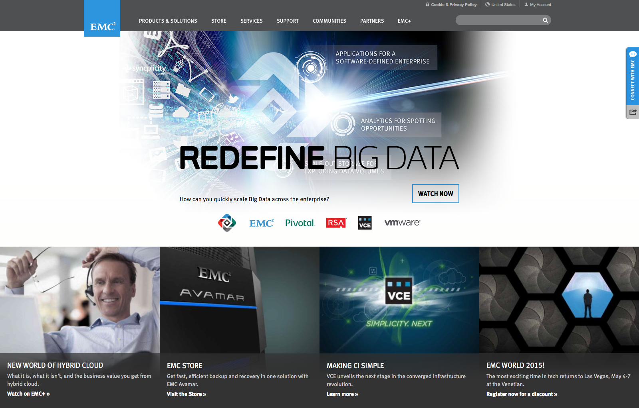

## LAYOUT

* Header: Products & Solutions | Store | Services | Support | Communities | Partners | EMC+ | [Search]
  + Cookie & Privacy Policy | i18n | My Account
* Splash Image: randomly displays one of two images onLoad.
  + 1) Advertises an upcoming EMC conference in Las Vegas.
  + 2) Invites you to watch streams from a previous conference.
  + Note: a third splash image is loaded when JavaScript is disabled.
* Tiles: highlight four content portals with an image, a title, description and link.
  + 1) Watch ‘Inovalon’s Data Lake Innovation’ on EMC+
  + 2) Visit the ‘EMC Store’
  + 3) Read ‘Big Data Game Changer’ on the Pulse Blog
  + 4) Register now for a discount to ‘EMC World 2015’
  + Note: entirely different tiles are loaded when JavaScript is disabled
* Footer:
  + 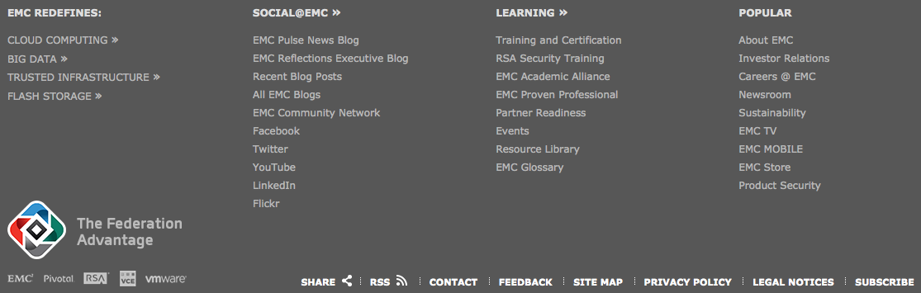
  + Legalese

## DESIGN

Accessibility

* JavaScript Disabled
  + Outdated splash image is loaded
  + Four outdated content tiles are loaded
  + The search feature fails to return results
  + Navigation does not dropdown additional options
    - Products & Solutions portal completely breaks (none of the options appear)
  + Navigation still collapses into a single button on mobile however the button doesn’t work
    - Therefor navigation totally breaks on JS disabled mobile
  + i18n breaks, making the default origin the only option
* CSS Disabled
  + Website is still navigable and consumable
  + There are many artifacts that do not exist with styles enable
  + Generally a sprawling mess
* Spotty use of the ‘alt’ tag; No meaningful keyboard navigation support

Aesthetics

* Homepage favors big, high-resolution graphics over textual information.
* Dropdown menu items match submenus that appear upon clicking a nav button12
* Three main fonts:
  + Serif font for EMC logo
  + Sans-serif font for content
  + Handwritten font overlay on primary splash image

Micro UX

* Fixed position navigation menu, contact and social media tabs.
* EMC ViPR “Welcome to Big, Big, Big Data” scrolling animation.3 [<http://www.emc.com/cloud/vipr/index.htm>]
* Moving backgrounds/Muted video previews. [<http://www.emc.com/enterprise-content-management/index.htm>]

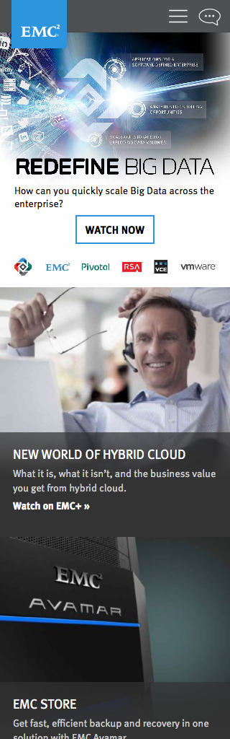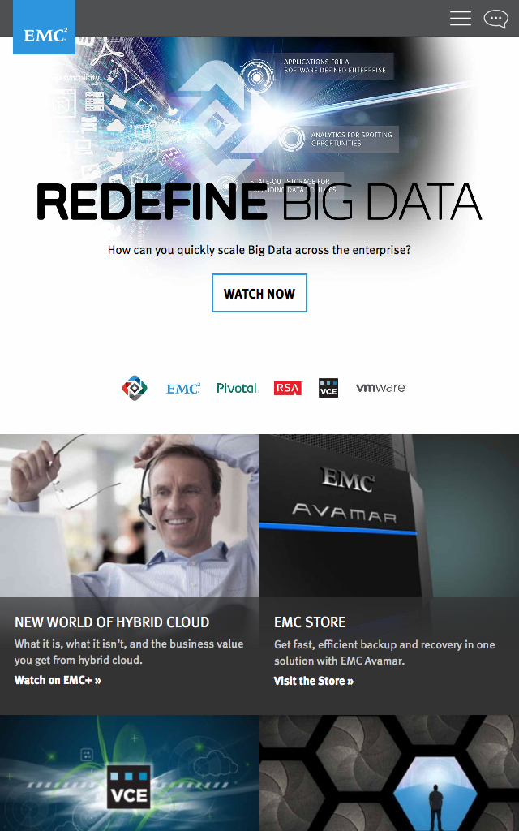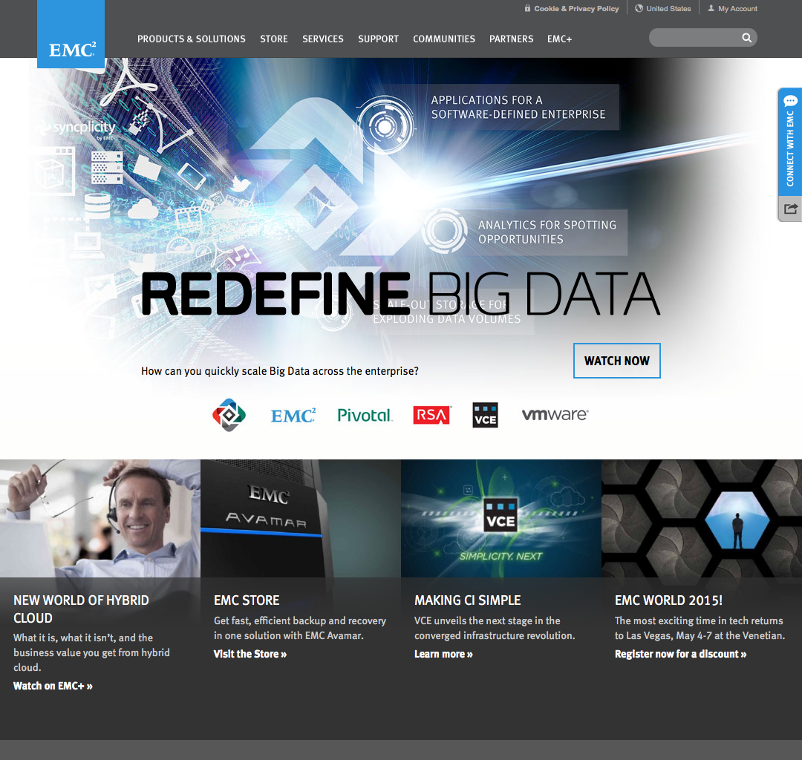

## RESPONSIVE DESIGN

* Navigation, Contact and Social Media collapse into two icons with touch-friendly menu
* Splash images scale down; Feature tiles scale down then stack top-down
* Homepage and newer pages responsively scale down to 320px width
  + Other pages are fixed-width at 1080px
* Moving backgrounds/Muted video previews become static images at smaller resolutions

# HP Storage

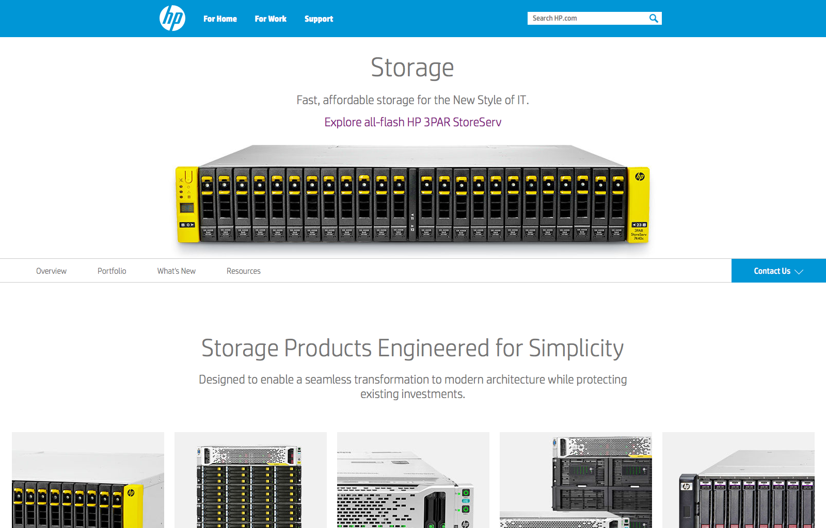

## LAYOUT

* Header: For Home | For Work | Support | [Search]
* Splash Image: ‘Explore all-flash HP 3PAR StoreServ’
* Scrolling Navigation: a secondary navigation bar moves the user down the page
  + Upon scrolling, the secondary navigation fixes itself to the top of the page
  + The link corresponding the part of the page you are in becomes underlined
  + 1) Overview: back to top
  + 2) Portfolio: horizontally scroll through product feature tiles; services and support
  + 3) What’s New: latest storage innovations
  + 4) Resources: horizontally scroll through resource feature tiles; sort relevant tiles with dropdown menu
  + Contact Us: dropdown menu attached to scroll navigation bar
* i18n
* Footer:
  + 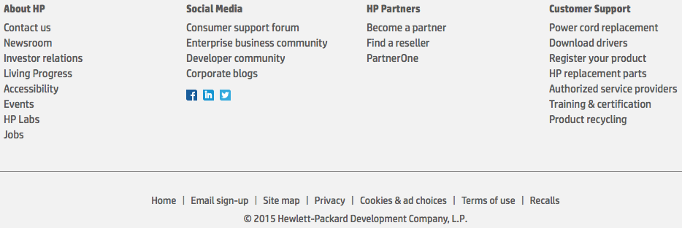

## DESIGN

Accessibility

* JavaScript Disabled
  + Responsive tiles and horizontal scrolling breaks
  + All dropdown menus break making essential navigation unusable
  + The search feature breaks
  + Scrolling navigation becomes static and the buttons do nothing
  + One of three ‘What’s New” tiles disappears
  + Resource tiles disappear
  + i18n breaks, making the default origin the only option
  + Still mobile responsive; however, all buttons are broken
* CSS Disabled
  + Well-ordered nested lists of links restore website navigability
  + No strange artifacts appear
* Many vital images have descriptive alt tags; No meaningful keyboard navigation support

Aesthetics

* Homepage features attractive product images and about one sentence of text per image
* A singular sans-serif font is used through the entire interface
* Negative/white space dominates the interface
* Each product and resource tile features one image, a title and short description

Micro UX

* Scrolling navigation bar fixes itself to the top upon scrolling down
  + Progress indicator updates upon scrolling5
* Horizontal tile scrolling adds an additional axis of information without enabling true horizontal scrolling
* A singular section with translucent background reveals a hidden background image of cityscape4
* [<http://www8.hp.com/us/en/products/data-storage/>]

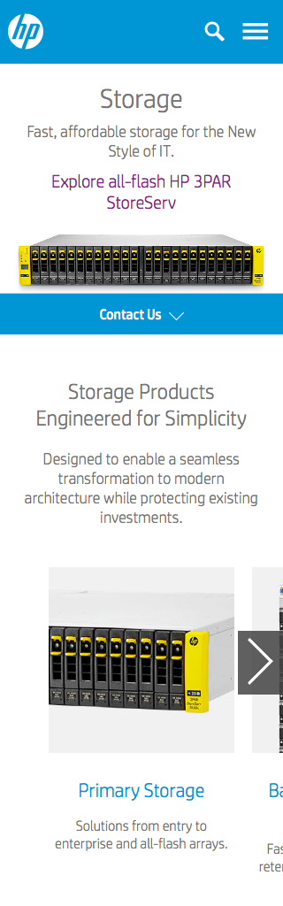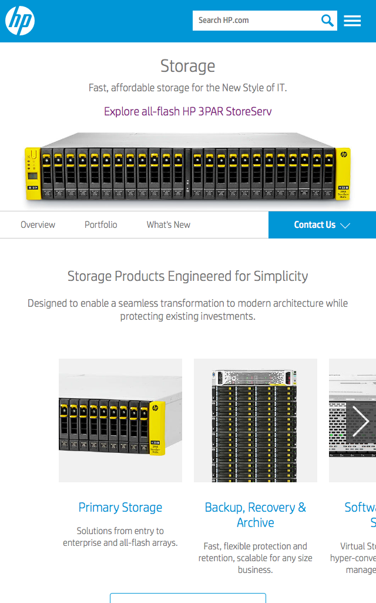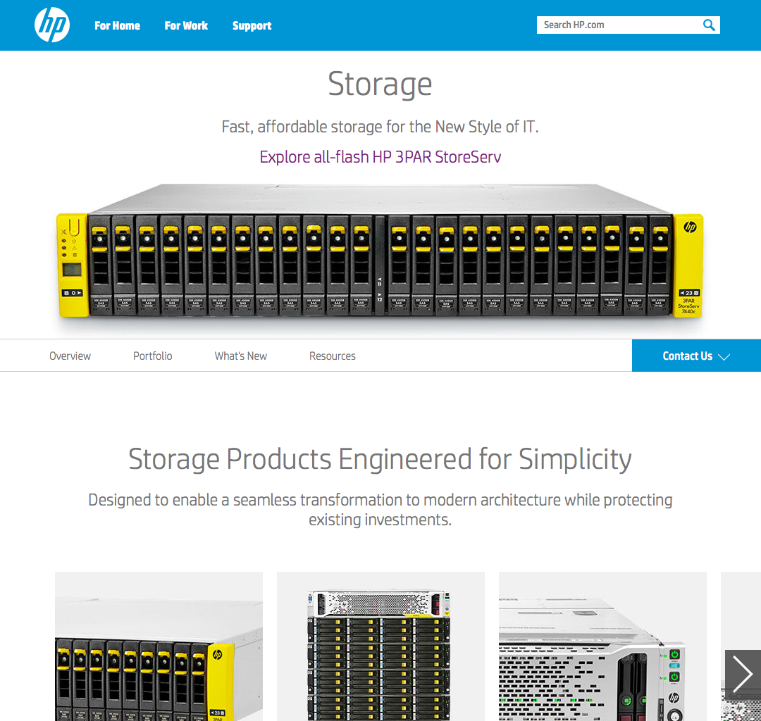

## RESPONSIVE DESIGN

* Navigation and search collapse into two icons with touch-friendly accordion menu
* Splash images scale down; Feature tiles scale down then stack top-down
* Homepage and newer pages responsively scale down to 320px width.
  + Other pages are fixed-width at 1080px.
* Click-based horizontal tile scrolling becomes click-and-drag only

# IBM Storage

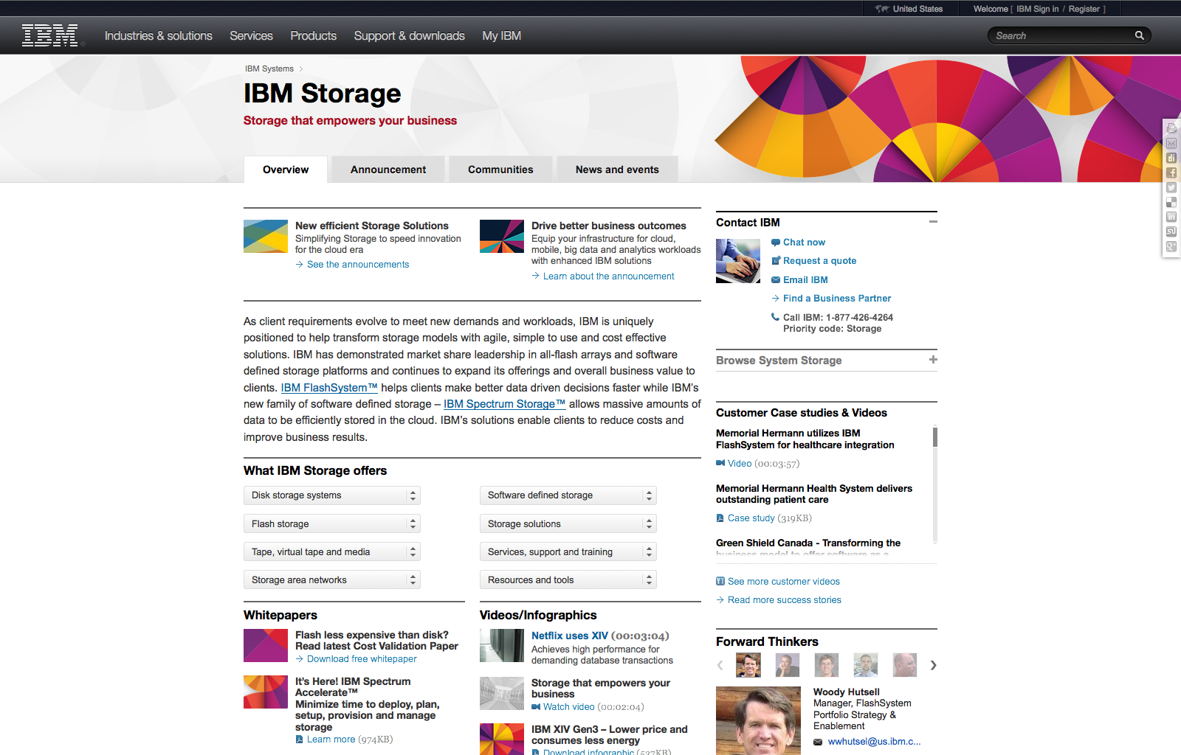

## LAYOUT

* Header: Industries & solutions | Services | Products | Support & downloads | My IBM | [Search]
  + i18n | Welcome – IBM Sign in / Register
* No splash image; IBM assaults you with a wall of text
* Overview | Annoucement | Communities | New and events
  + tab graphics communicate a file\folder metaphor; each tab actually loads a new page
* Two ‘announcements’ top the ‘Overview’ page with small, arbitrary graphics, a title, short description and link
* A paragraph of plain text describes how IBM is uniquely positioned to meet new demands and workflows
* Eight dropdown menus detail extensive lists of IBM storage offers,
  + Disk storage systems, flash storage, tape, storage area networks, software defined storage, storage solutions, services, support, training, resources and tools
* “Tiles” featuring small and mostly arbitrary graphics, descriptive titles and links offer information about,
  + Whitepapers, Videos/Infographics, Events, and Webcasts and Offers
* A ‘More’ section offers links to additional, jargon-laced resources
* A ribbon of content features random products and services like,
  + An app, an e-Book, midsize business solutions and transitioning IBM x86 to Levovo
* A column along the right advertises additional resources and information
  + ‘Contact IBM’, ‘Browse System Storage’, ‘Customer Case studies’, featured ‘Forward Thinkers’, social media links, community testimonies and another random article
* Footer:
  + 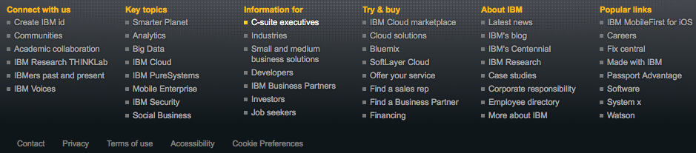

## DESIGN

Accessibility

* JavaScript Disabled
  + Nothing breaks
  + A few features change aesthetically but remain fully functional
    - The navigation header changes to just ‘Site map’
    - Dropdown menus lose their styling
    - The community testimonies become a list instead of a slideshow
  + Sign In\Register disappears
  + ‘Forward Thinkers’ disappears
* CSS Disabled
  + Website is logically ordered with clear titles and information
  + Nothing breaks
  + I actually like this more than the styled layout
  + Enabling JS with CSS disabled produces a few artifacts, adds more images and disorganizes things a bit
* Found a single alt tag
* Search and ‘What IBM Storage offers’ support keyboard navigation – basically meaningless
* IBM offers an entire section dedicated to their stance on accessibility
  + They also offer a software package at no charge to improve accessibility

Aesthetics

* Homepage favors blocks of textual information. Resembles a newspaper
* A single sans-serif font with a variety of sizes and shades of grey

Micro UX

* Fixed position social media tab on the right
* Textual slideshow highlights community testimonies

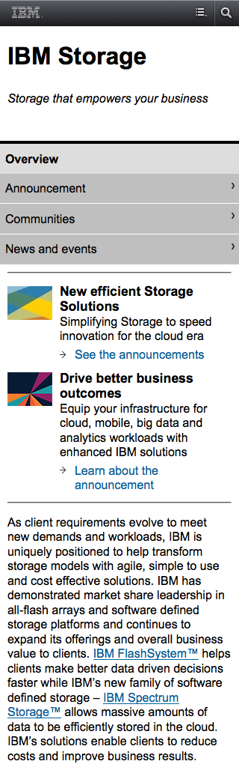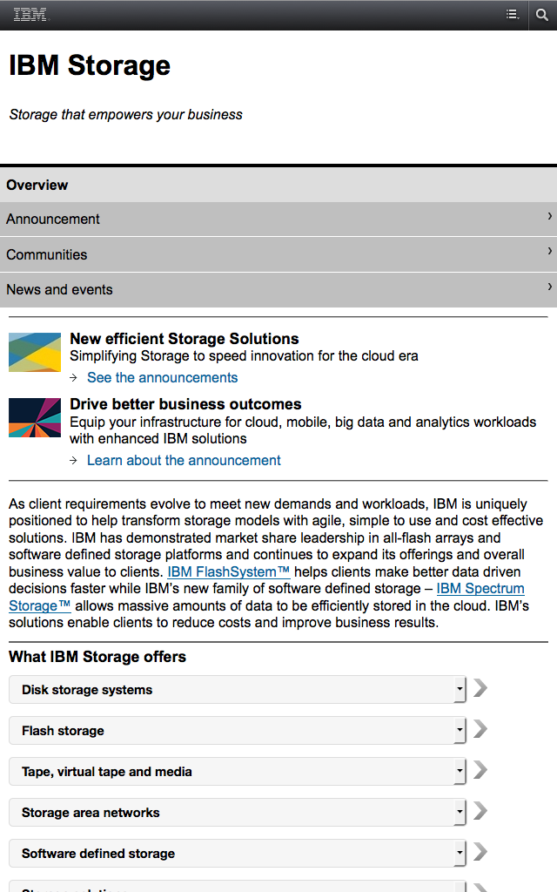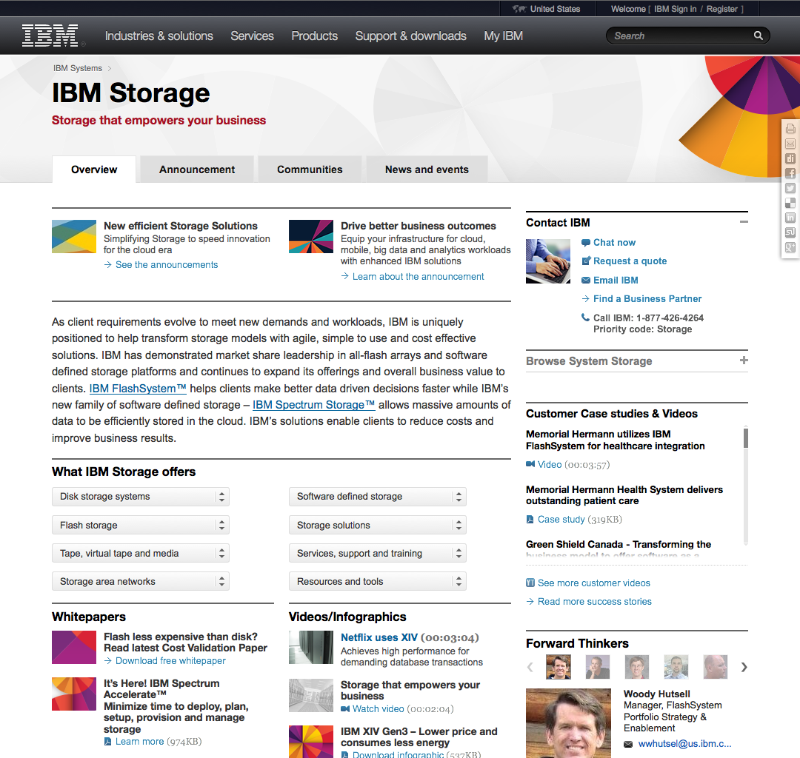

## RESPONSIVE DESIGN

* Rather than making their website responsive, IBM serves a separate interface to mobile users
* Every element on the page gets stacked
* Header navigation is replaced by any icon which opens the site map
* ‘Forward Thinkers’ disappears; Community testimonies become a list instead of a slideshow
* Website detects whether or not the user is on a cellular network, not clear why

# NetApp

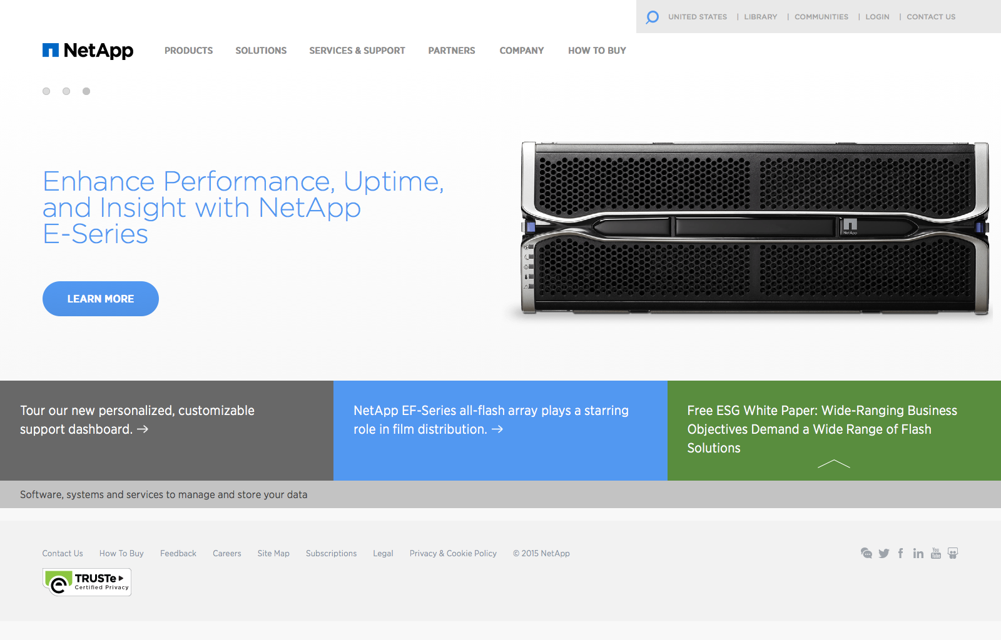

## LAYOUT

* Header: Products | Solutions | Services & Support | Partners | Company | How to Buy
  + Extensive submenus featuring multiple navigation paradigms popup onHover
  + [Search] | i18n | Library | Communities | Login | Contact Us
  + 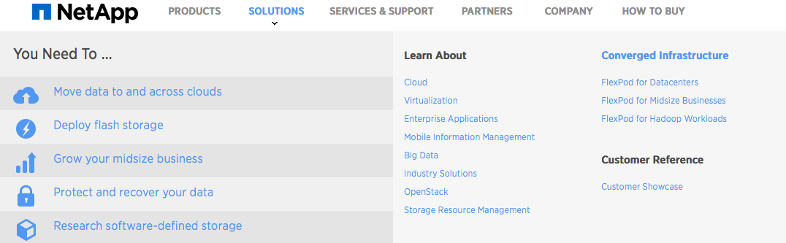
* Slideshow: fade transitions between three features
  + Includes, a descriptive title, a ‘Learn More’ button and a high resolution descriptive/relevant graphic
  + 1) Attend AWS 2015
  + 2) Accelerate performance with Netapp EF-Series all flash array
  + 3) Enhance performance with Netapp E-Series
* Minimalist Flat UI interface feature three news items as clickable white text titles on solid color background
  + 1) Tour our customizable support dashboard
  + 2) NetApp EF-Series all-flash array plays starring role in film distribution
  + 3) Free white paper: wide-ranging objectives demand wide range of flash solutions
    - click to expand green block, adds form for e-mail, country, checkboxes and ‘download’ button
* Tagline: ‘Software, systems and services to manage and store your data’
* Footer:
  + 

## DESIGN

Accessibility

* JavaScript Disabled
  + Navigation drop-down becomes buggy but remains technically functional
  + Slideshow elements stack top-down
    - Slideshow graphics layer over one another
  + ‘Free ESG White Paper’ pop-out breaks
  + i18n breaks, making the default origin the only option
  + Search feature no longer responds
  + Live Chat silently fails
  + Most forms still function
* CSS Disabled
  + Restores country selector options
  + Turns navigation drop-down into a nested list — fully accessible
  + Well organized; most graphics disappear; however, site remains fully usable
* Minor use of the ‘alt’ tag; No meaningful keyboard navigation support – advance slideshow with left/right arrows

Aesthetics

* Flat UI design
  + Supports clear navigation and transmission of information
  + Emphasizes restrained use of high resolution images
  + Lots of negative/white space and modest use of text
* A single non-serif font with a nice variety of sizes, weights and colors

Micro UX

* Slideshows
* Submenus with multiple user-oriented navigation structures
  + i.e. “What do you need to do?” vs. “What do you what to learn about?”

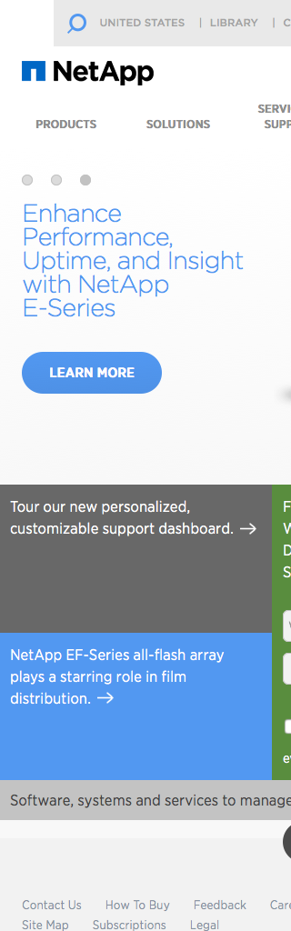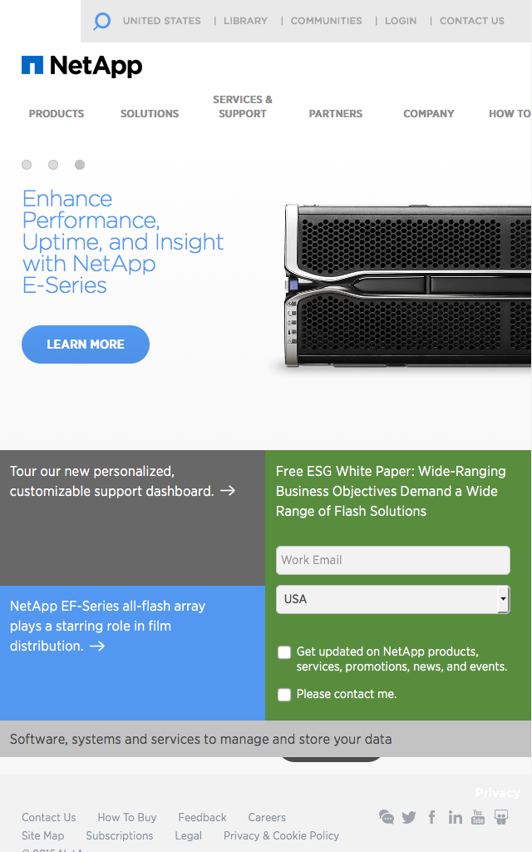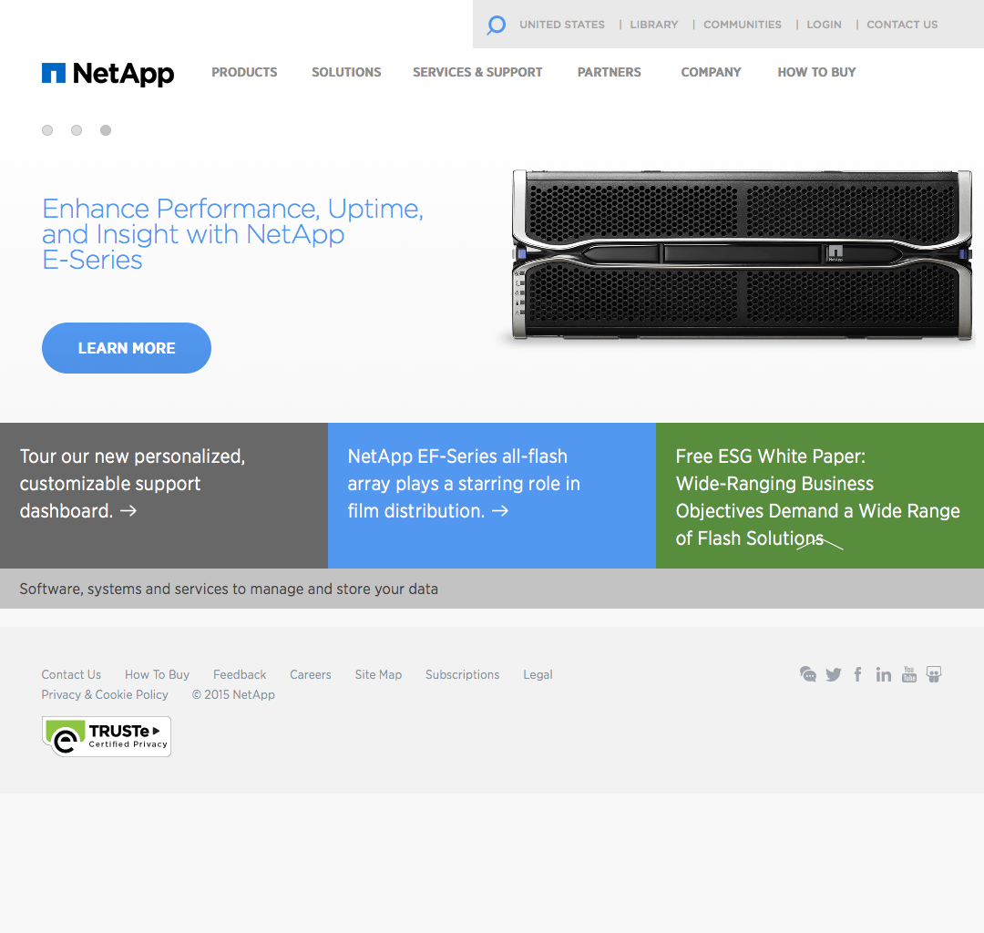

## RESPONSIVE DESIGN

* Responsive down to about 640px-750px width
* Elements resize but generally do not change position–resulting in very narrow content elements at 640px width
* ‘Free ESG White Paper’ element pops out and becomes static

# Pure Storage

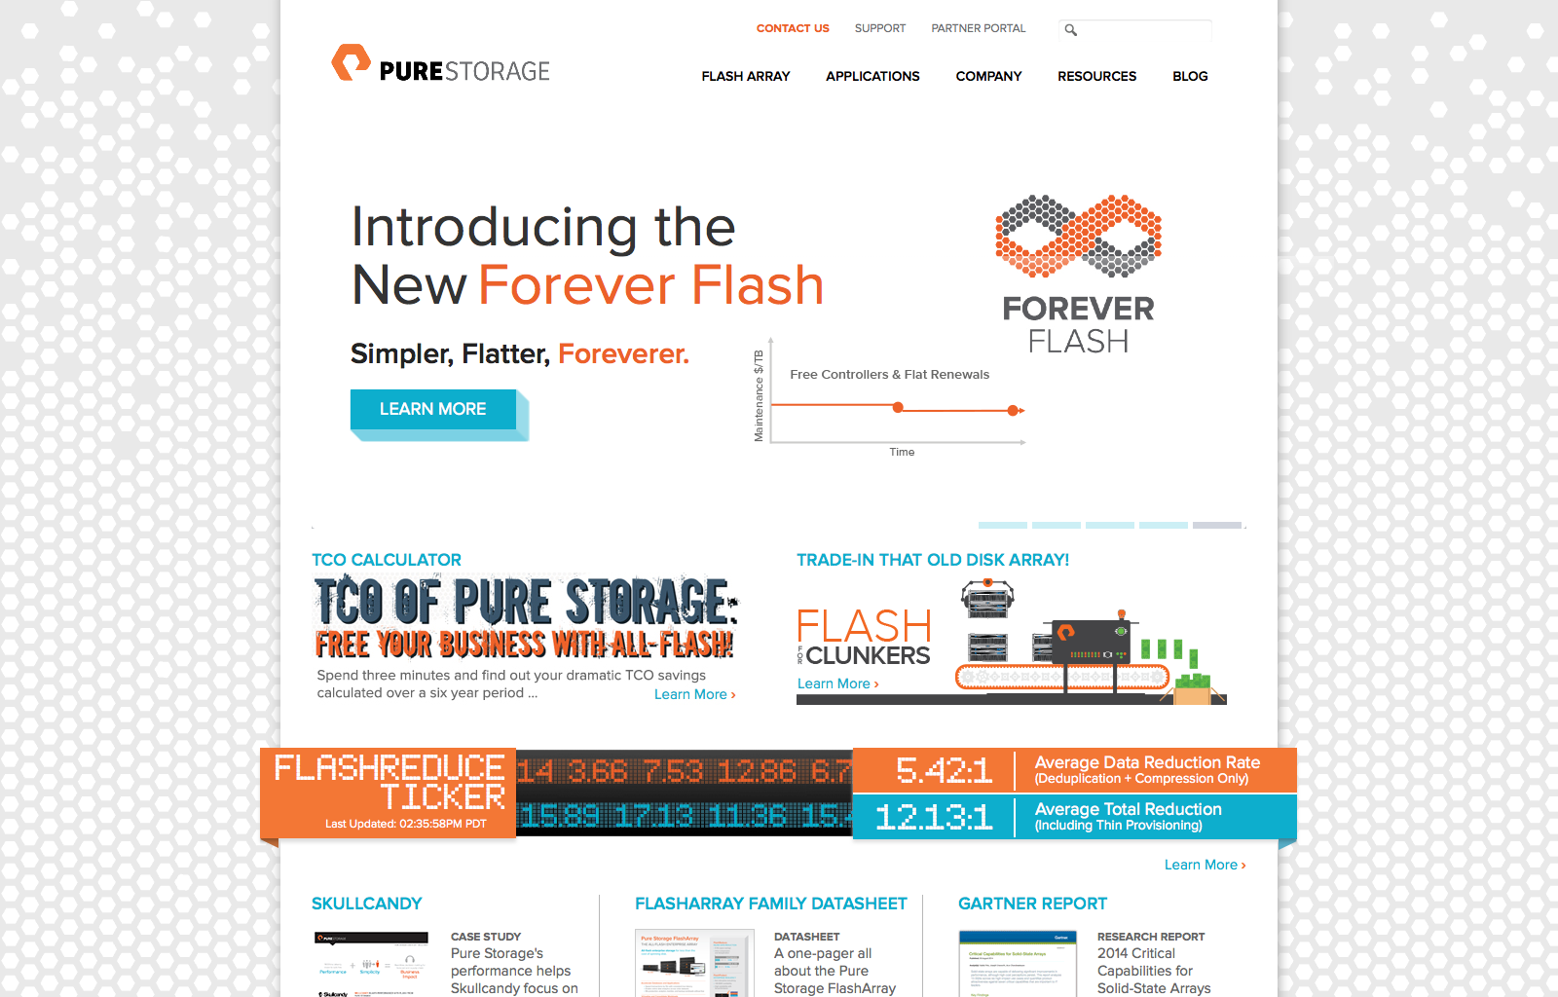

## LAYOUT

* Header: Flash Array | Applications | Company | Resources | Blog
  + Contact Us | Support | Partner Portal | [Search]
* Slideshow: Fade transitions between five features
  + Automated slide advancement ceases once the user manually selects a slide
* ‘TCO Calculator’: Six-year savings calculator tools helps convince users to go All-Flash
* ‘Trade-In That Old Disk Array’: Flash for Clunkers .gif animation
* ‘Flashreduce Ticker’: Attractive CSS stock market-style ticker animation
* Three “tiles” feature video testimonials and a datasheet
  + Title, graphic, descriptive text, and button
* ‘What’s New’ advertises
  + Recent news stories, case studies, and whitepapers
  + Recent blog posts
  + The most recent @PureStorage tweet
    - with accompanying buttons to follow Pure Storage on Twitter and Facebook
* Footer:
  + 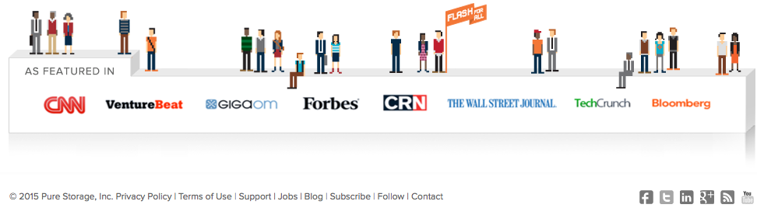

## DESIGN

Accessibility

* JavaScript Disabled
  + Destroys the homepage’s legibility – elements are stacked all over one another
    - Most other pages retain their integrity
  + Ticker animation breaks
  + The navigation menu and all links continue to function
  + The search box disappears
  + All font changes slightly
* CSS Disabled
  + Website is still navigable and consumable
  + There are many artifacts that do not exist with styles enabled
  + JavaScript becomes unresponsive with styles disabled
* Proper use of the ‘alt’ tag; No meaningful keyboard navigation support
* No i18n options can be found

Aesthetics

* Flat UI and Sprite-based graphics create a pleasant experience
* Interface edges on being too cluttered
* A standard sans-serif font is used throughout the website
  + Unique graffiti-esque font and blocky “ticker” fonts punctuate the site

Micro UX

* A .gif animation featured on the homepage (.gif’s are generally frowned upon presently)
* A CSS-based animated ticker6
* Sprite-based icons and graphics communicate a playful and hip, game-ified, feel

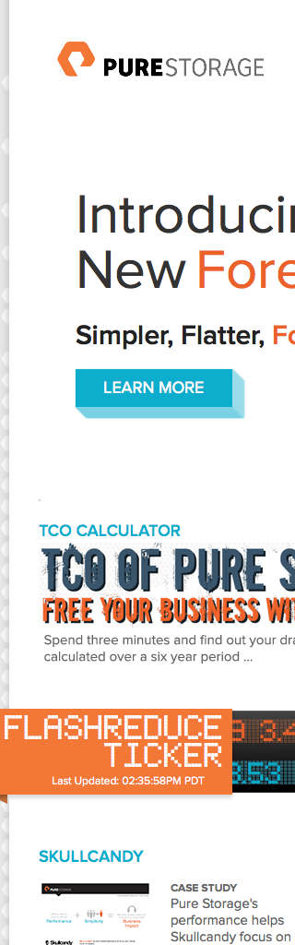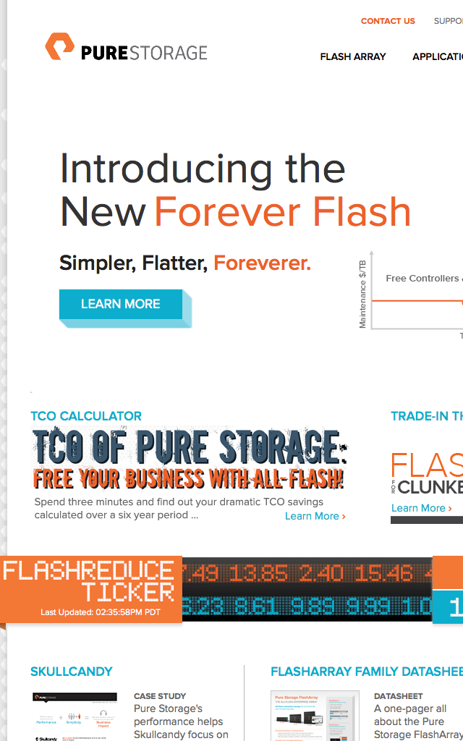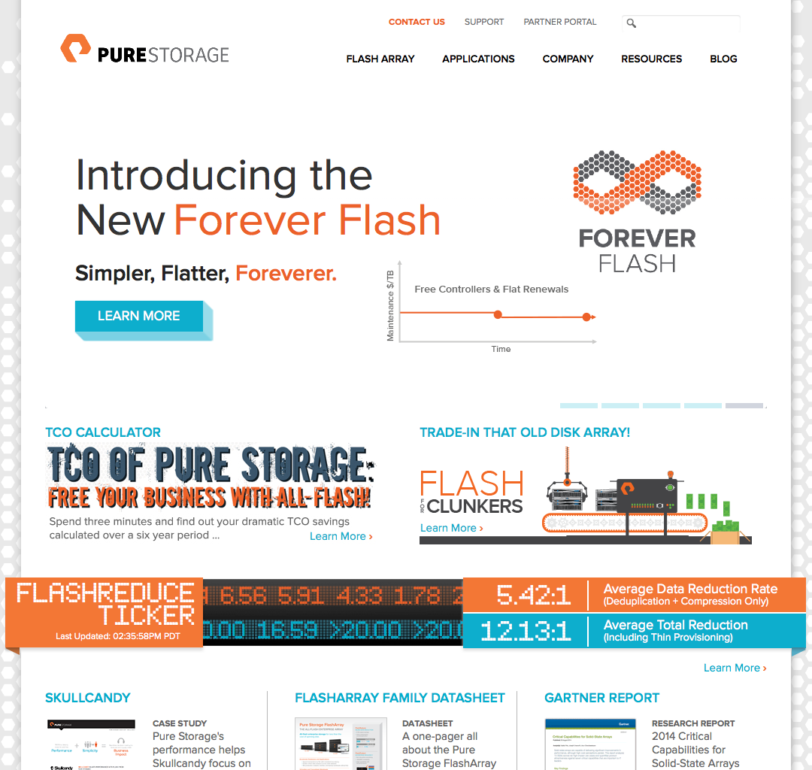

## RESPONSIVE DESIGN

* Despite utilizing multiple contemporary design standards, like Flat UI and CSS animation,
  + The website has zero responsiveness

# GOOGLE SEARCH RESULTS

# Macintosh HD:Users:jrafalko:Documents:Corporate Web:Competitor Audits:emcGoogle.pngMacintosh HD:Users:jrafalko:Documents:Corporate Web:Competitor Audits:hpGoogle.png

# Macintosh HD:Users:jrafalko:Documents:Corporate Web:Competitor Audits:pureGoogle.pngMacintosh HD:Users:jrafalko:Documents:Corporate Web:Competitor Audits:netappGoogle.png

# UI Sugar Reference Sheet

1. [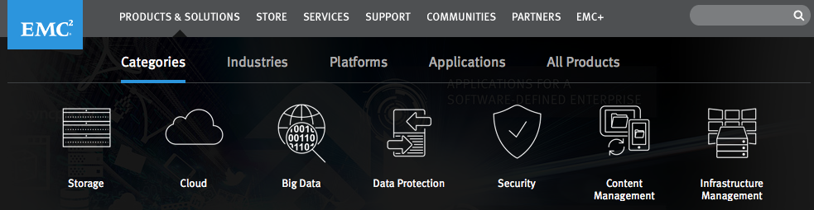](http://www.emc.com)
2. [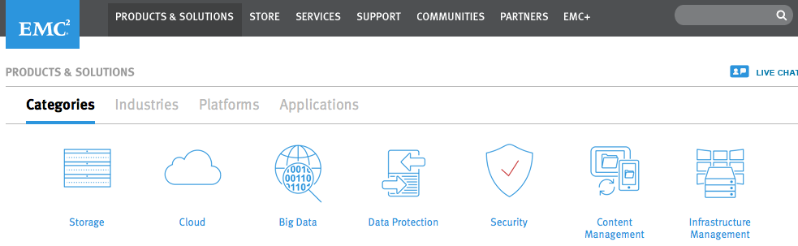](http://www.emc.com)
3. [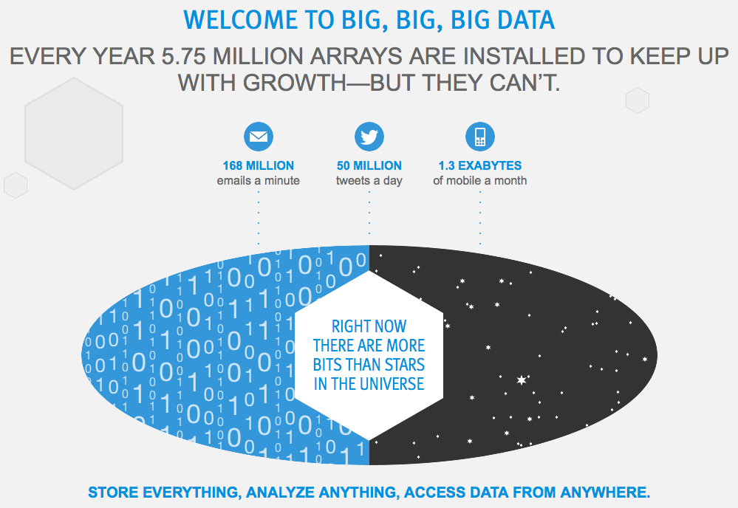](http://www.emc.com/cloud/vipr/index.htm)
4. [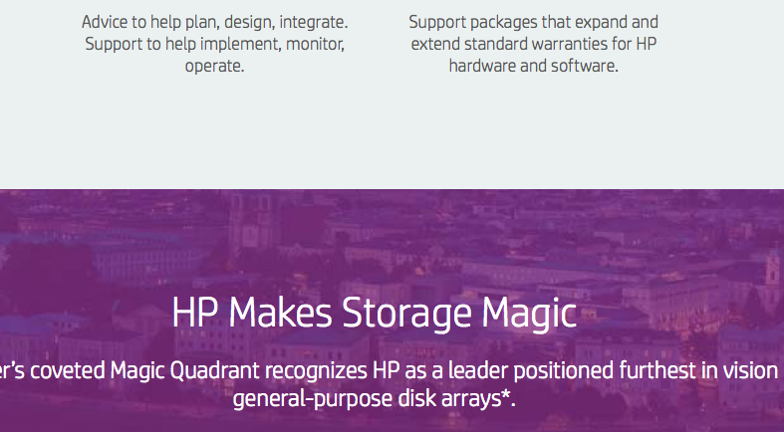](http://www8.hp.com/us/en/products/data-storage/)
5. [](http://www8.hp.com/us/en/products/data-storage/)
6. [](http://www.purestorage.com/)